|  |  |
| --- | --- |
|  | **FPT ACADEMY INTERNATIONAL**  **FPT – APTECH COMPUTER EDUCATION** |

**Centre Name: ACE-HCMC-2-FPT.**

**Address: 590 Cach Mang Thang 8, District 3, Ho Chi Minh City, Viet Nam.**

**A1Uniforms**

|  |  |  |
| --- | --- | --- |
| **Supervisor.** | Mr. Nguyen Phat Tai | |
| **Batch.** | T1.2209.E0 | |
| **Group.** | Group 1 | |
| **Serial No.** | **Enrollment Number** | **Student Name** |
| 1. | Student1416070 | Nguyen Ngoc Thanh Chuong |
| 2. | Student1420703 | Quang Đai Vi |
| 3. | Student1418261 | Đinh The Dan |
| 4. | Student1420696 | Le Thanh Thien |

Month 12 Year 2022

**This is to certify that**

**Mr.:**

Nguyen Ngoc Thanh Chuong

Quang Dai Vi

Đinh The Dan

Le Thanh Thien

**has successfully designed & developed**

eProject: A1uniforms website

**Submitted by: Nguyen Ngoc Thanh Chuong**

**Date of issue: 14-Jan-2021**

**Authorized Signature: Chương**

**TABLE OF CONTENTS**

ACKNOWLEDGEMENT 3

SYNOPSIS 3

PROBLEM DEFINITION 3

CUSTOMER'S REQUIREMENTS SPECIFICATIONS (CRS) 4

Business/Project Objective: 4

Hardware/ Software Requirements: 5

SCOPE OF THE WORK (IN BRIEF) 6

Architecture and design of the system 7

Diagram of the website 8

TASK SHEET REVIEW 1 9

SITE MAP 10

MOCK OF THE WEBSITE 11

1.HOME 12

2.BRAND 13

3.BOY/GIRL UNIFORMS 14

4.CONTACT 15

5.FEEDBACK 16

TASK SHEET REVIEW 2 17

WEBSITE DESCRIPTION 18

**1.**HomePages**...............................................................................................................................18**

**2.**Products**................................................................................................................................. 20**

**3.** Brands Page **..........................................................................................................................23**

**4.** Contact Us Page**.......................................................................................................................24**

**5.** About Us Page **.........................................................................................................................25**

**6.** Feedback **................................................................................................................................26**

TASH SHEET REVIEW 3 27

# ACKNOWLEDGEMENT

Regarding to the A1Uniforms project, we Group 1 would like to express our deepest appreciation to our teacher, Mr. Nguyen Phat Tai for his support and enthusiasm. It would not have been completed without his wise advice throughout the process of doing it. The outcome is also the proof of the hard work and effort of all the members of the group. We believe that it still needs to be improved since this is the very first project that we have participated so far and we are looking forward to receiving all the comments. A1Uniforms website project is certainly a remarkable milestone in our carriers of pursuing the dream of becoming professional developers. Last but not least, we share this goal with our families for all the unconditional love and motivation that they have given to us.

# SYNOPSIS

A1Uniforms is into selling Uniforms. Company has been selling these products for last 20 years. They have a wide range of Appliances. The company advertises by distributing the pamphlets, advertising on television and so on. Due to rapid development in internet field, the company decides to launch a website where people will get all the information about the various products available with them easily.

# PROBLEM DEFINITION

The Web site is to be created based on the following requirements.

1. The home page must describe the keywords or highlight of the shop along

with all navigation link defined.

2. Products should be categorized as

a. Shirts

b. Skirts

c. Frocks

d. P.T. T-shirts

e. P.T. shorts

f. P.T. track pants

g. Belts

h. Ties

i. Logos

j. Socks

3. The “Contact Us” page should have the Address of the Company and the mail

address which when clicked will invoke the local mail client from where they

can send an email. Address of the Company should be displayed using

GeoLocation API (e.g. GoogleMaps).

4. Contact Us page should also include the address and contact details of various

outlets of A-1 uniforms in the city.

5. About us page

6. Feedback

7. Navigation must be smooth.

8. Color combination must be uniform throughout the project.

# CUSTOMER'S REQUIREMENTS SPECIFICATIONS (CRS)

**Client: A1Uniforms**

### Business/Project Objective:

The Objective of this program is to give a sample project to work on real life projects. These applications help you build a larger more robust application.

The objective is not to teach you JavaScript/Dreamweaver but to provide you with a real life scenario and help you create basic applications using the tools.

You can revise the chapters before you start with the project.

This project is meant for students who have completed the module of ***HTML5.*** These programs should be done in the Lab sessions with assistance of the faculty if required.

It is very essential that a student has a clear understanding of the subject. Students should go through the project and solve the assignments as per requirements given.

Kindly get back @ [eprojects@aptech.ac.in](mailto:eprojects@aptech.ac.in) in case of any doubts regarding the application or its objectives.

**Input to the system:**

- Browsing products based on brands, type of appliances..

**Output from the system:**

* A menu that will categorize all the functions of the site.
* Display the list of available albums category wisely.
* Provide Feedback page for customers.
* The location of the company is in Contact Us page.
* Besides the above requirements, the site should have look and feel as per the industry standards.

**Expected delivery date:** 14-Jan-2022.

**List of deliverables:**

* + - * Document Word.
      * User Guide.
      * Source code.

### Hardware/ Software Requirements:

**Hardware**

* + A minimum computer system that will help you access all the tools in the courses is a Pentium 166 or better.
  + 64 Megabytes of RAM or better.

**Software**

* + Notepad/HTML editor.
  + Dreamweaver, VisualStudioCode.
  + IE 5.0/ Netscape 6.0.

# SCOPE OF THE WORK (IN BRIEF)

**The team has discussed and has agreed about the website layout as shown briefly below:**

**1.Homepage**: Showing brief introduction about the company and type of products that it is selling.

**2.Brands**: Containing its products with their details and images categorized by brands of the products.

**3.Boy’s Uniform**: Classify products by gender.

**4.Girl’s Uniform**: Classify products by gender.

**5.Accessories**:Accessories for each product.

**7.Contact Us**: Showing the contact information of the company such as address, location map, mobile, fax, email.

**8.Feedback**: Customers’ feedback about our products.

**9**.**About Us:** Introducing the history, archivements and further information about the company.

# Architecture and design of the system

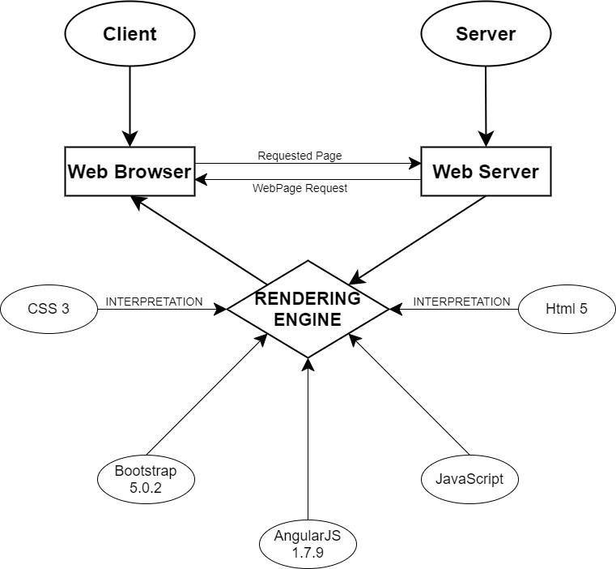

# Diagram of the website

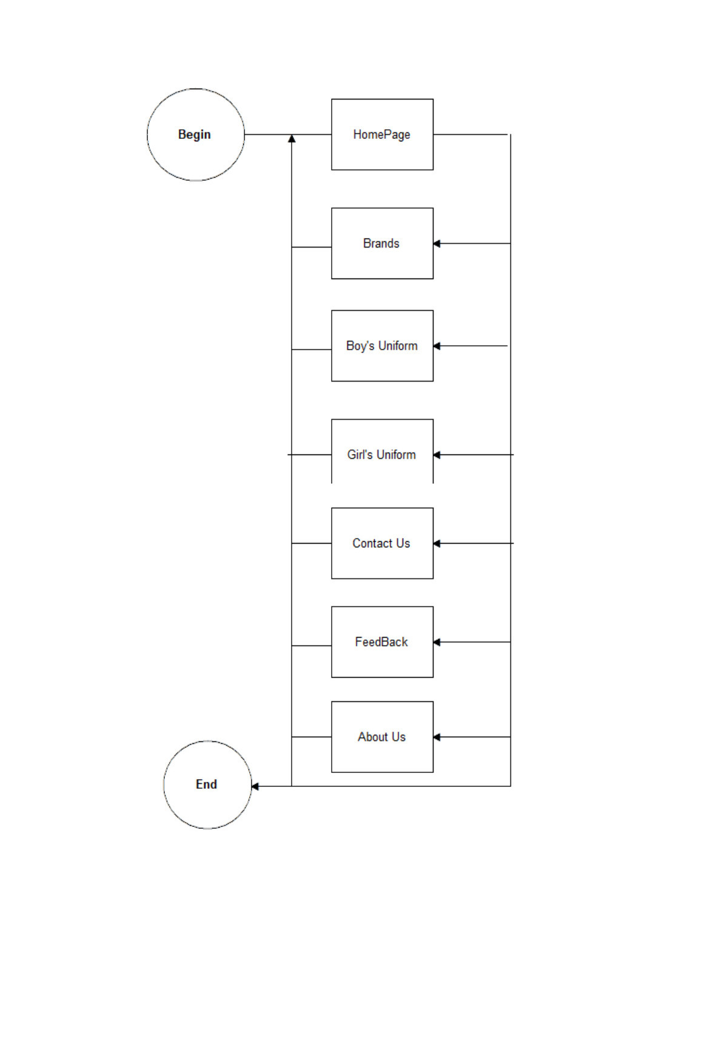



# TASK SHEET REVIEW 1

|  |  |  |  |  |  |  |  |
| --- | --- | --- | --- | --- | --- | --- | --- |
| **Project Ref. No.:**  **eP/Advertisement Portal Management**  **System/01** | | **Project Title:** | **Activity Plan Prepared By:** | **Date of Preparation of Activity Plan:** | | | |
| **Sr.**  **No.** | **Task** | **Actual**  **Start Date** | **Actual Days** | **Team**  **Mate Names** | **Status** |
| 1 | Problem Statement | A1Uniforms | Chuong | 14-Dec-2022 | 1 | Thien,Chuong | Completed |
| 2 | Analysis of the requirements about the website | 14-Dec-2022 | 1 | Dan,Vi | Completed |
| 3 | The scope of the work (in brief) | 14-Dec-2022 | 1 | Thien,Chuong | Completed |
| 4 | Architecture and design of the system | 14-Dec-2022 | 1 | Thien,Chuong | Completed |
| 5 | Diagram of the website | 14-Dec-2022 | 1 | Vi,Dan | Completed |
| 6 | Task Sheet | 14-Dec-2022 | 1 | Chuong | Completed |

|  |  |
| --- | --- |
| **Date: 21/12/2022** | |
| Signature of Instructor:  **Mr. Nguyen Phat Tai** | Signature of Team Leader:    **Mr.Nguyen Ngoc Thanh Chuong** |

**MOCK OF THE WEBSITE**

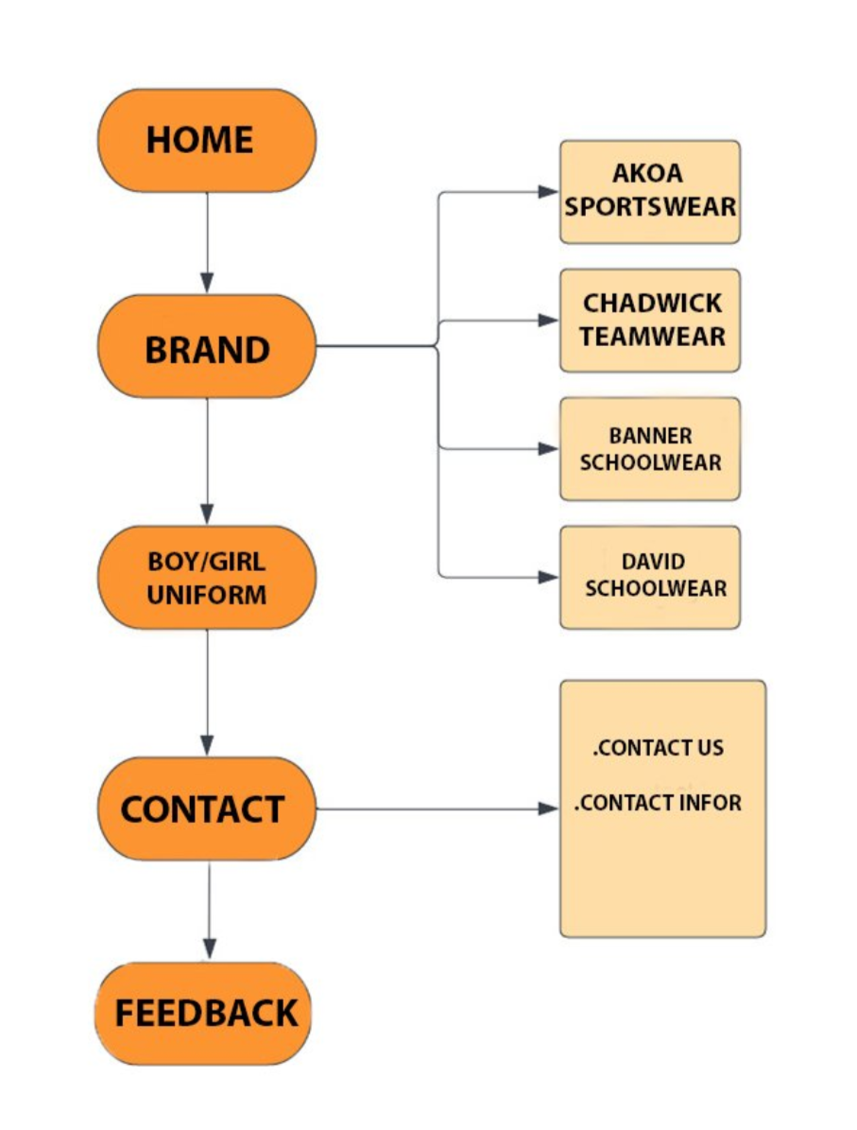

**1.Home**

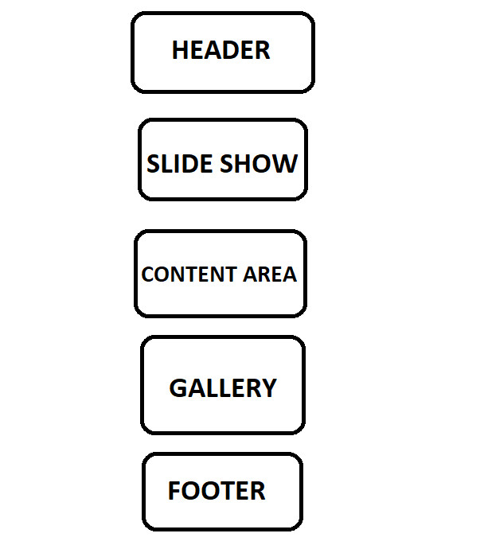

**2/Brands**

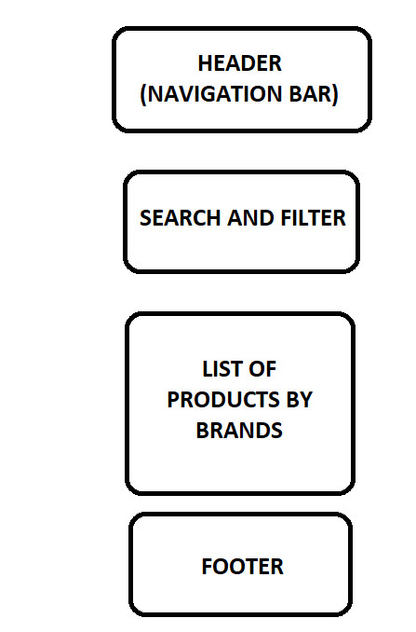

**3.Boy/Girl Uniforms**



**4.Contact**

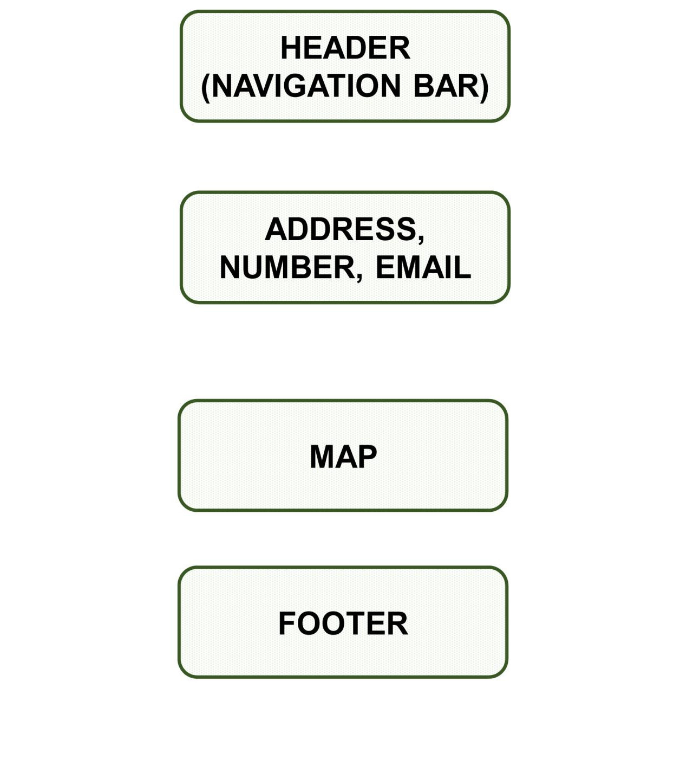

**5.Feedback**

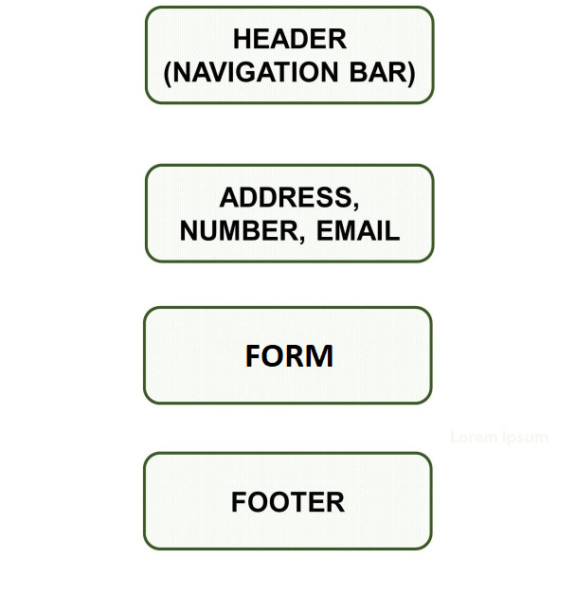

**TASK SHEET REVIEW 2**

|  |  |  |  |  |  |  |  |
| --- | --- | --- | --- | --- | --- | --- | --- |
| **Project Ref. No.:**  **eP/Advertisement Portal Management**  **System/01** | | **Project Title:** | **Activity Plan Prepared By:** | **Date of Preparation of Activity Plan:** | | | |
| **Sr.**  **No.** | **Task** | **Actual Start Date** | **Actual Days** | **Team Mate Names** | **Status** |
| 1 | Edit Home page | Amazing Bridges | Chương | 20-Dec-2022 | 1 | Vi,Thiên | Completed |
| 2 | JSON file | 24-Dec-2022 | 1 | Chương,Dân | Completed |
| 3 | Pages (About us, contact, gallery..v.v..) | 26-Dec-2022 | 1 | Chương,Dân | Completed |
| 4 | Site map and mock of the website | 28-Dec-2022 | 1 | Vi,Thiên | Completed |
| 5 | Task Sheet | 30-Dec-2022 | 1 | Vi,Thiên | Completed |
| **Date: December 30th, 2022** | | | | | | | |
| Signature of the Instructor:  Tai  **Mr. Nguyễn Phát Tài** | | | | Signature of the Leader:  Chuong  **Mr. Nguyễn Ngọc Thanh Chương** | | | |

# WEBSITE DESCRIPTION

1. **HOME PAGE:**

* Description

Home page displays following information:

* Slideshows of the news about Uniforms.
* Current top selling products of shop.
* Footer contains links to company’s social platforms.
* Show the informations of the shop in the left corner.
* Screenshot

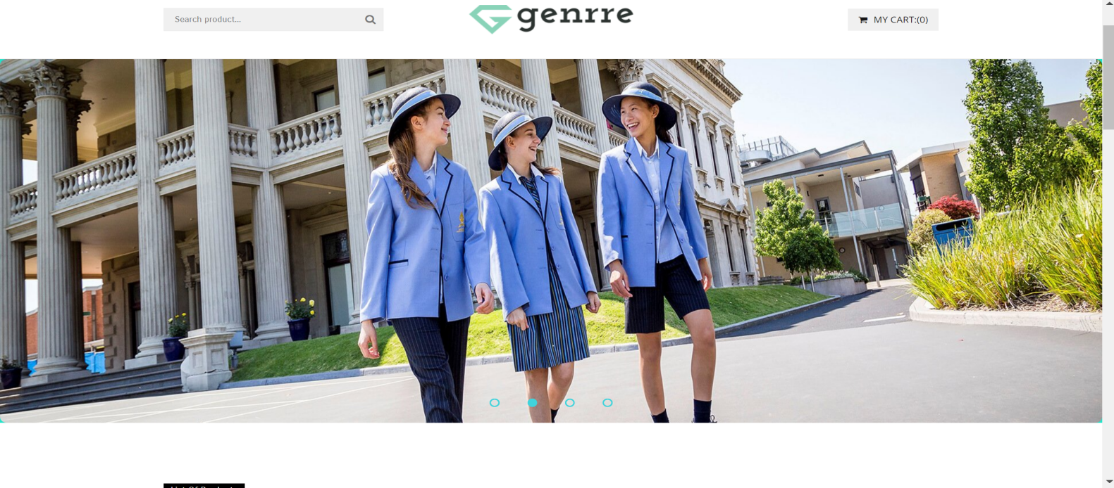

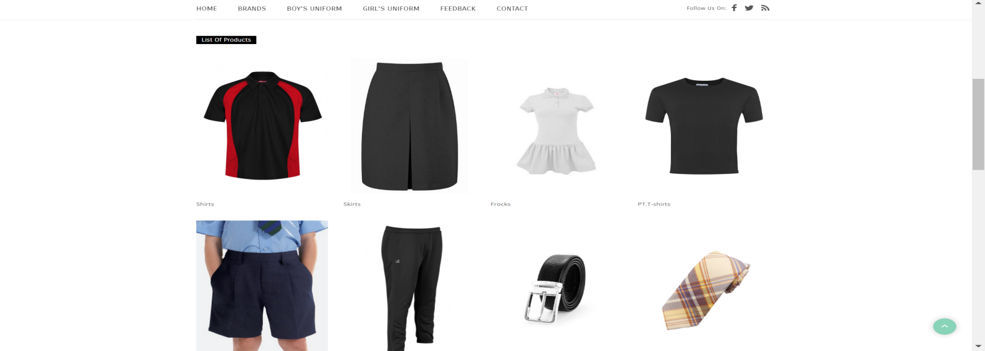

**Figure 1.1:** Homepage slideshow, top sellers and informations of the shop

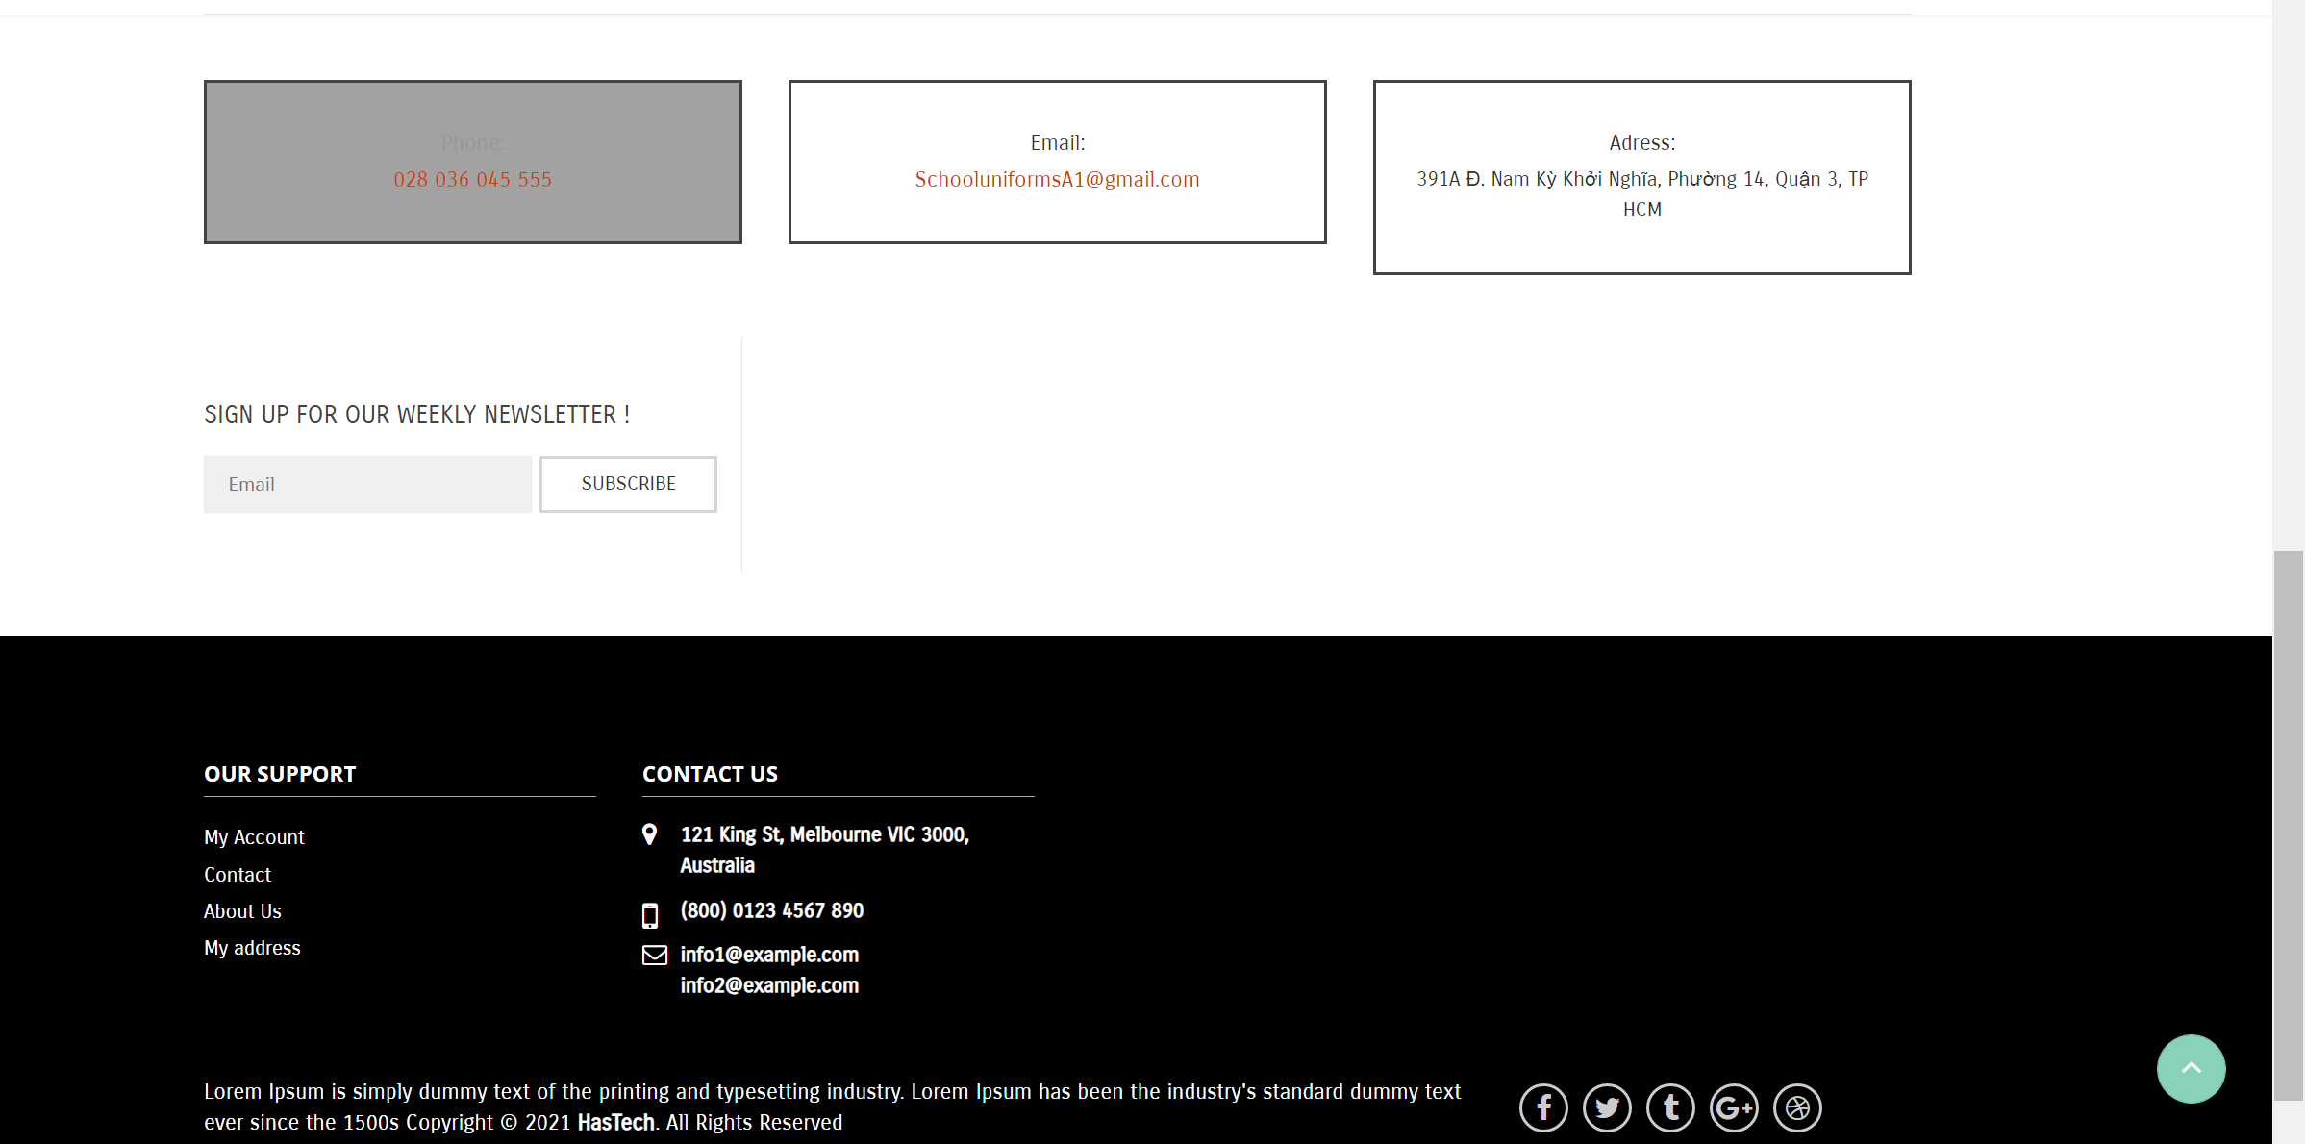

**Figure 1.2:** Footer

1. **PRODUCTS:**

* Description

This page contains various products with their information sorted by their type (shirts, skirts, tops,…). People can also search products by their names and filter them. The details products will be shown when clicking on them.

* Screenshot

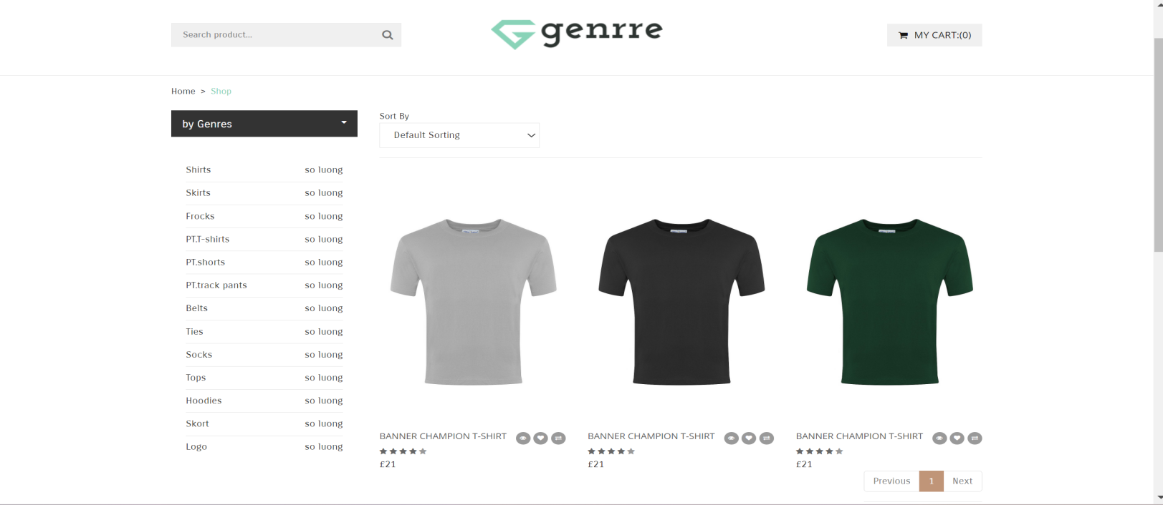

**Figure 2.1:** T-shirts

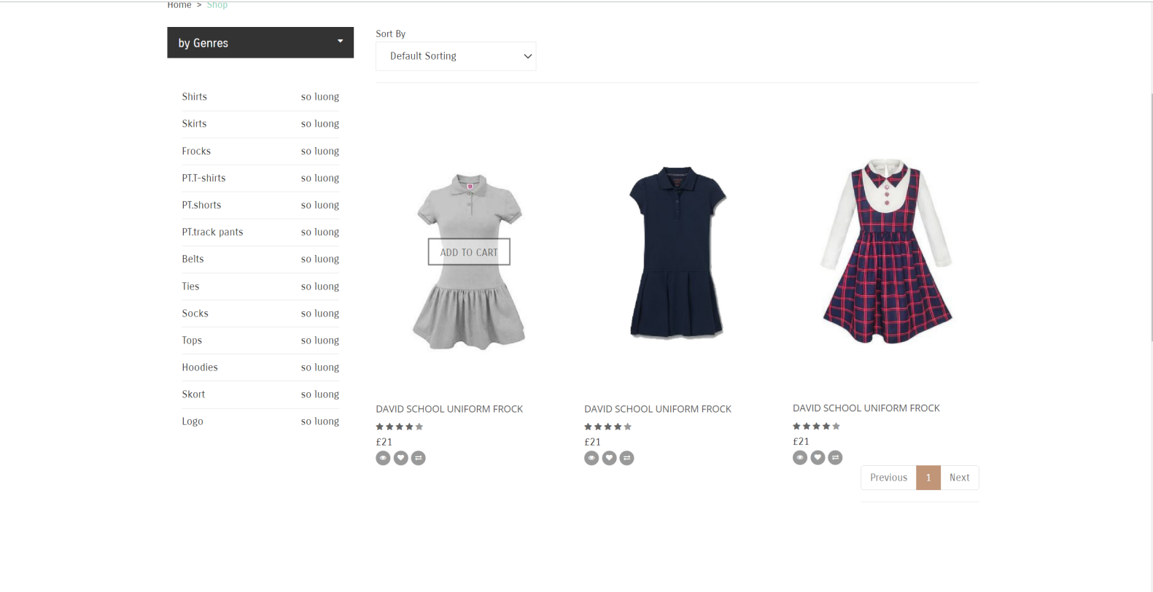

**Figure 2.4:**  Frocks

1. **BRANDS :**

* Description

This is also a page of products on sale with details but sorted by brands of the products (Akoa Sportswear, Chadwick Teamwear, Banner Schoolwear,David Schoolwear). The details products will be shown when clicking on them.

* Screenshot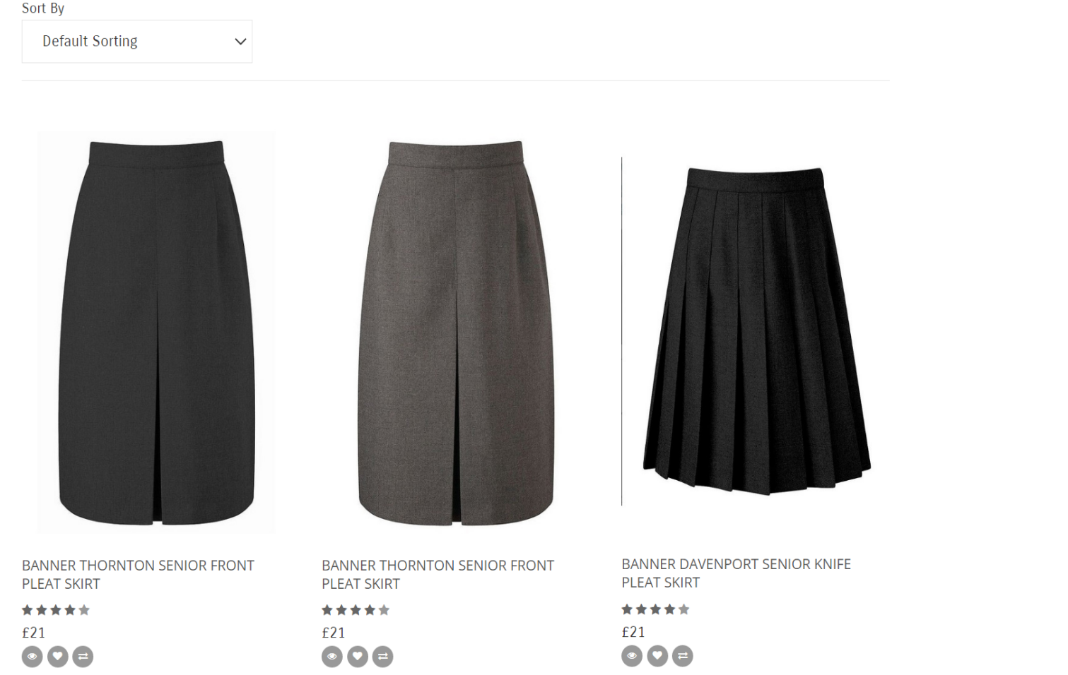

**Figure 3.1:** Brands Banner 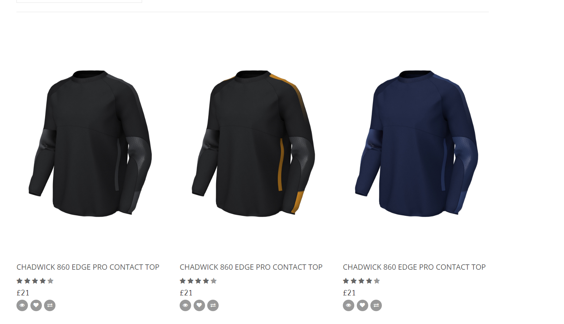

**Figure 3.2:** Brands Chadwick

1. **Boy’s uniform and Girl’s uniform:**

* Description:

Easily categorize products by gender. The details products will be shown when clicking on them.

* Screen shot:

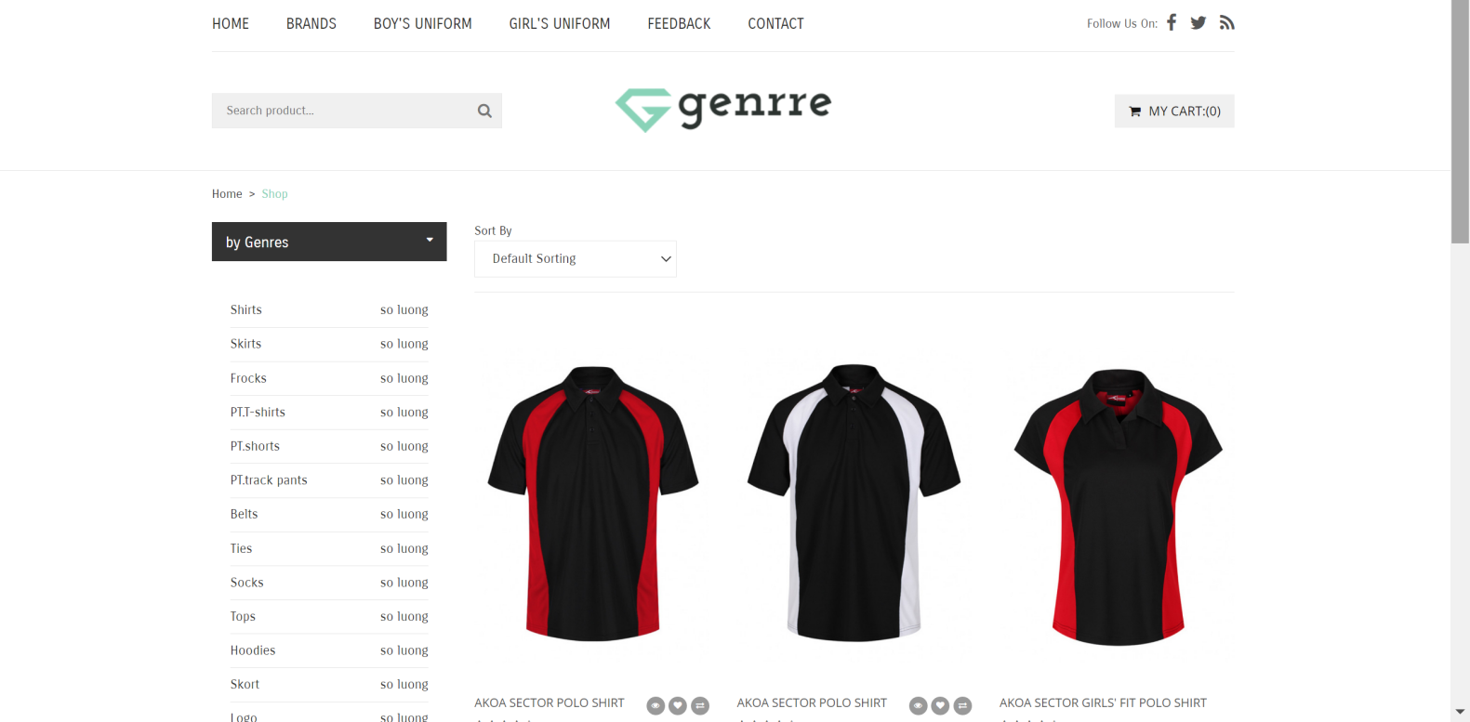

**Figure 3.3:** Boy’s uniforms

1. **ABOUT US PAGE:**

* Description:

This is the page about the history and the scope of the company. This include the important milestones of the company’s lifetime up to now. It also shares some stories about the development of Glasses.com and also the scope, the vision in the future.

* Screen shot

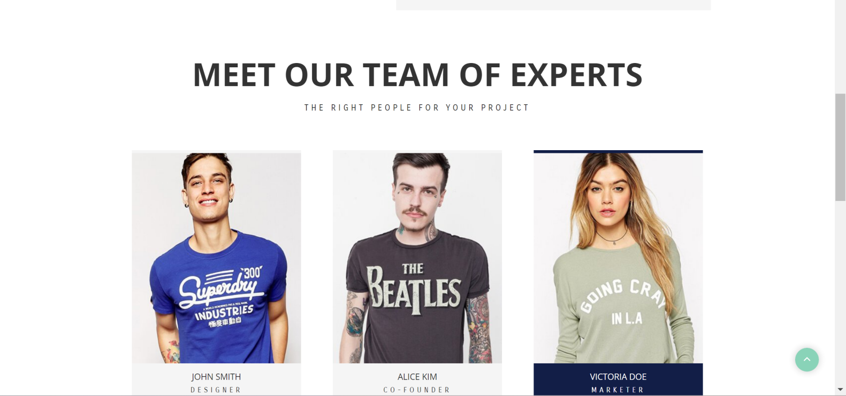

**Figure 3.4:** About us

1. **Feedback**

* Description:

An information page about customer reactions to one or more products. Information used as a basis for website improvement

* Screen shot

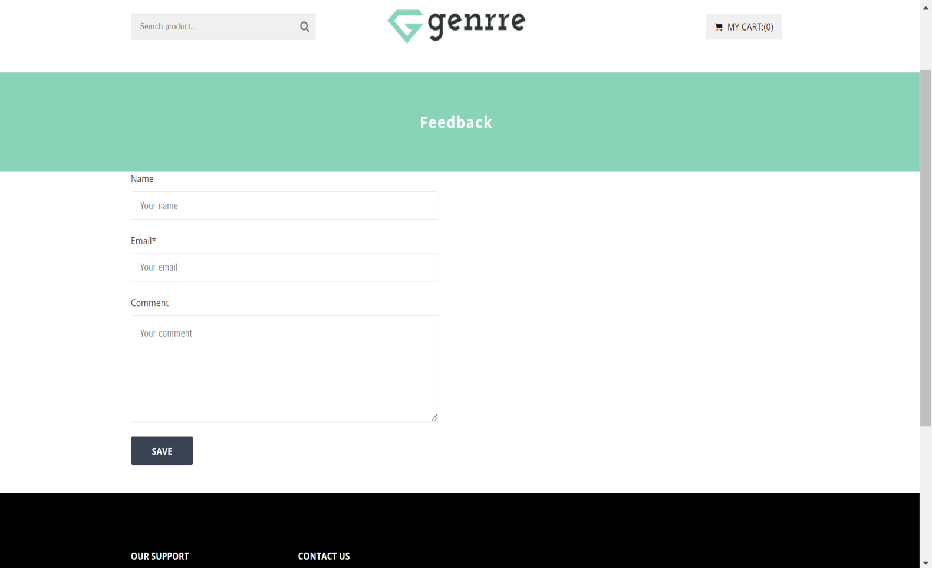

**Figure 3.5:** Feedback

1. **Contact us**

* Description:

The information of A1uniforms.com along with the form including the message that customer want to give the management team are given in this page. A google map about the location of the company is also provided here.

* Screen shot

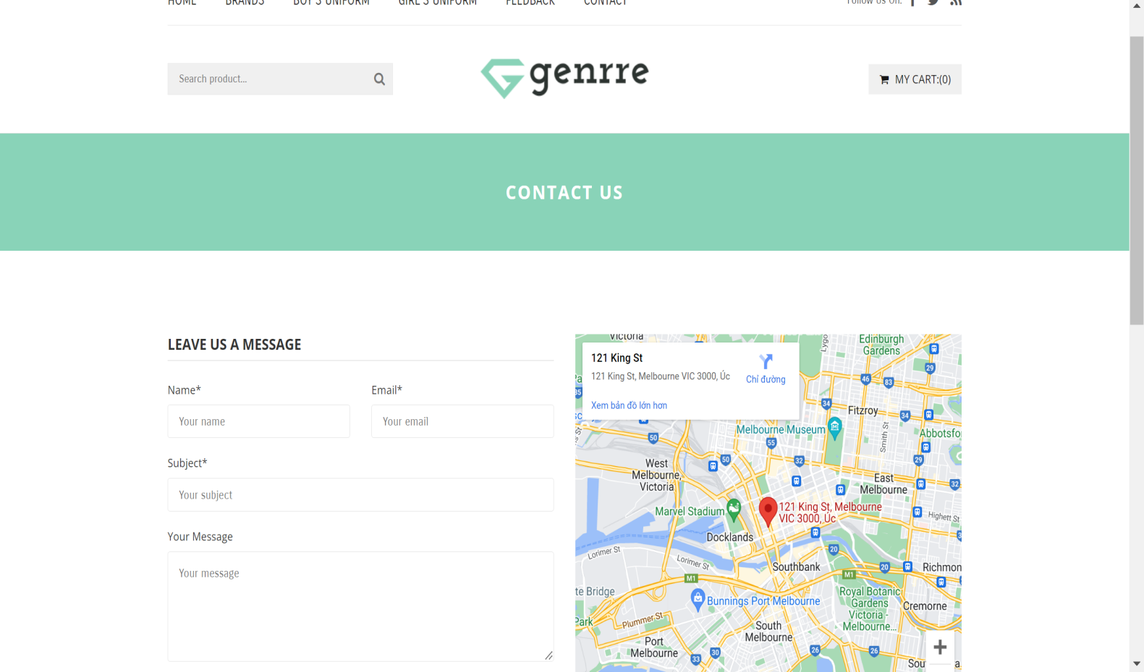

**Figure 3.6:** Contact us

**HTML, CSS, JAVASCRIPT DESCRIPTION**

**Home page**

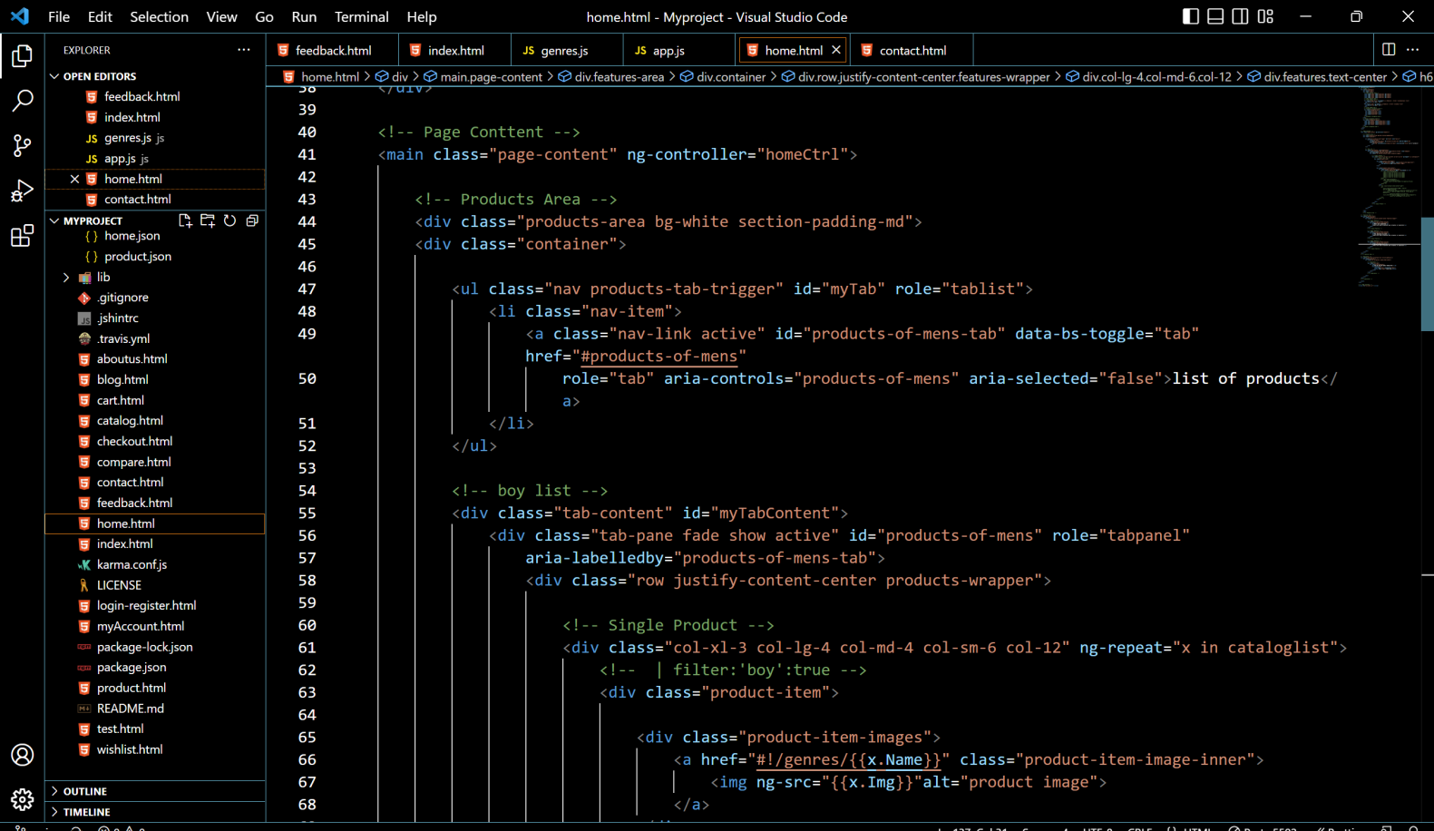

**Products**

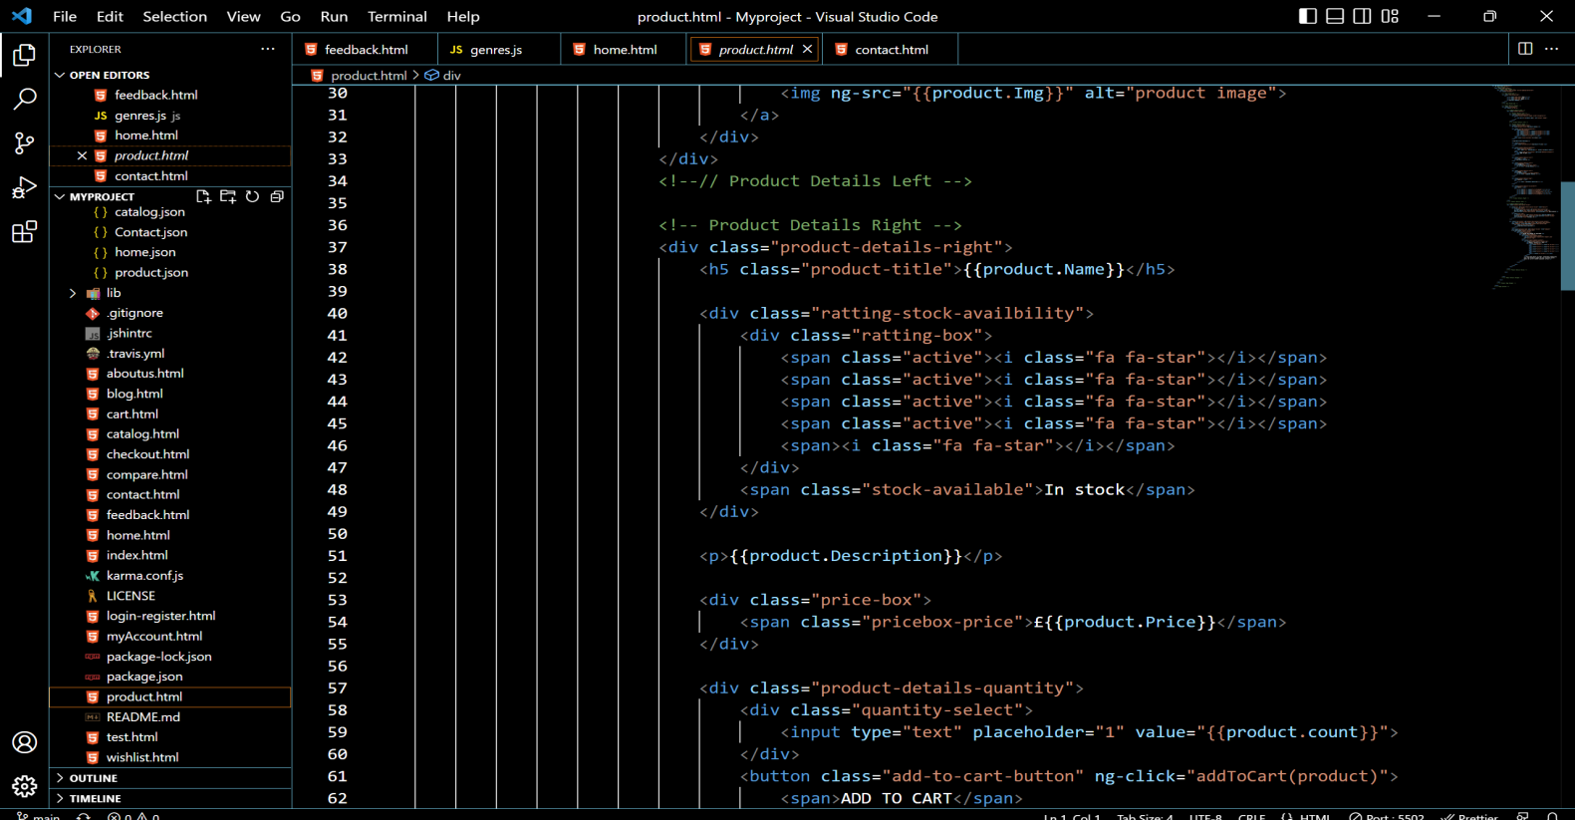

**Brands**

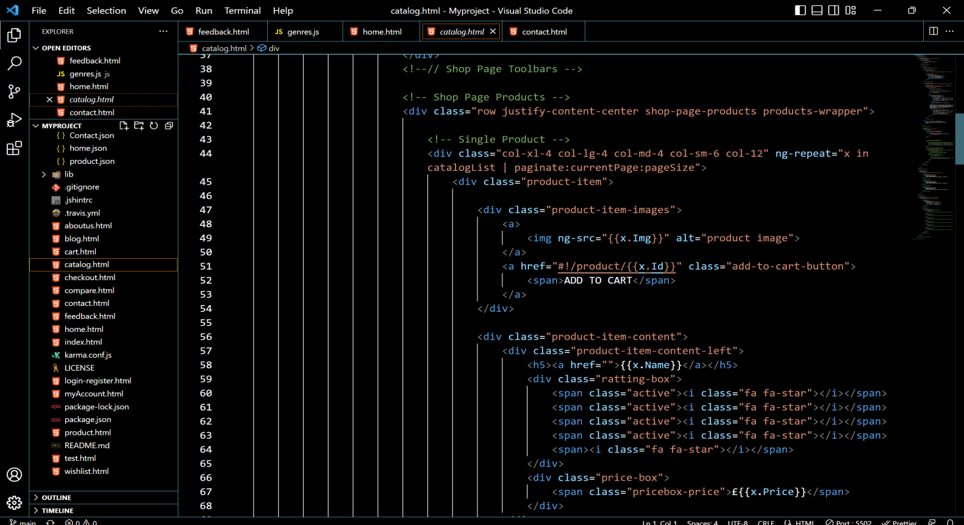

**Feedback**

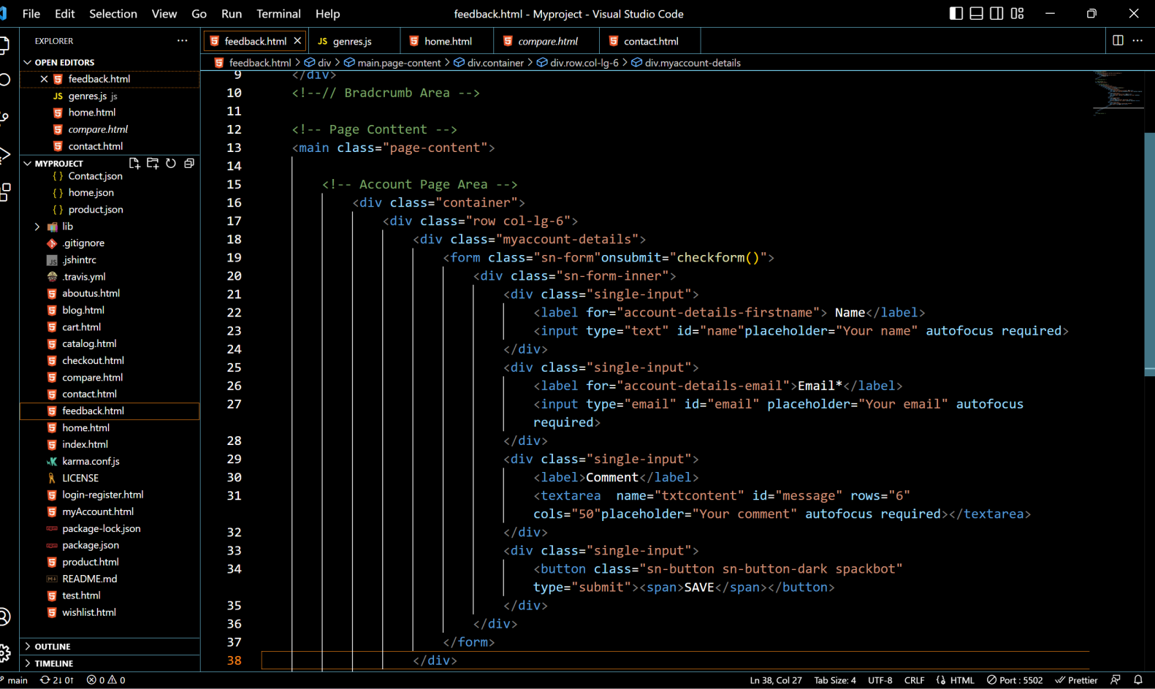

**About Us page**

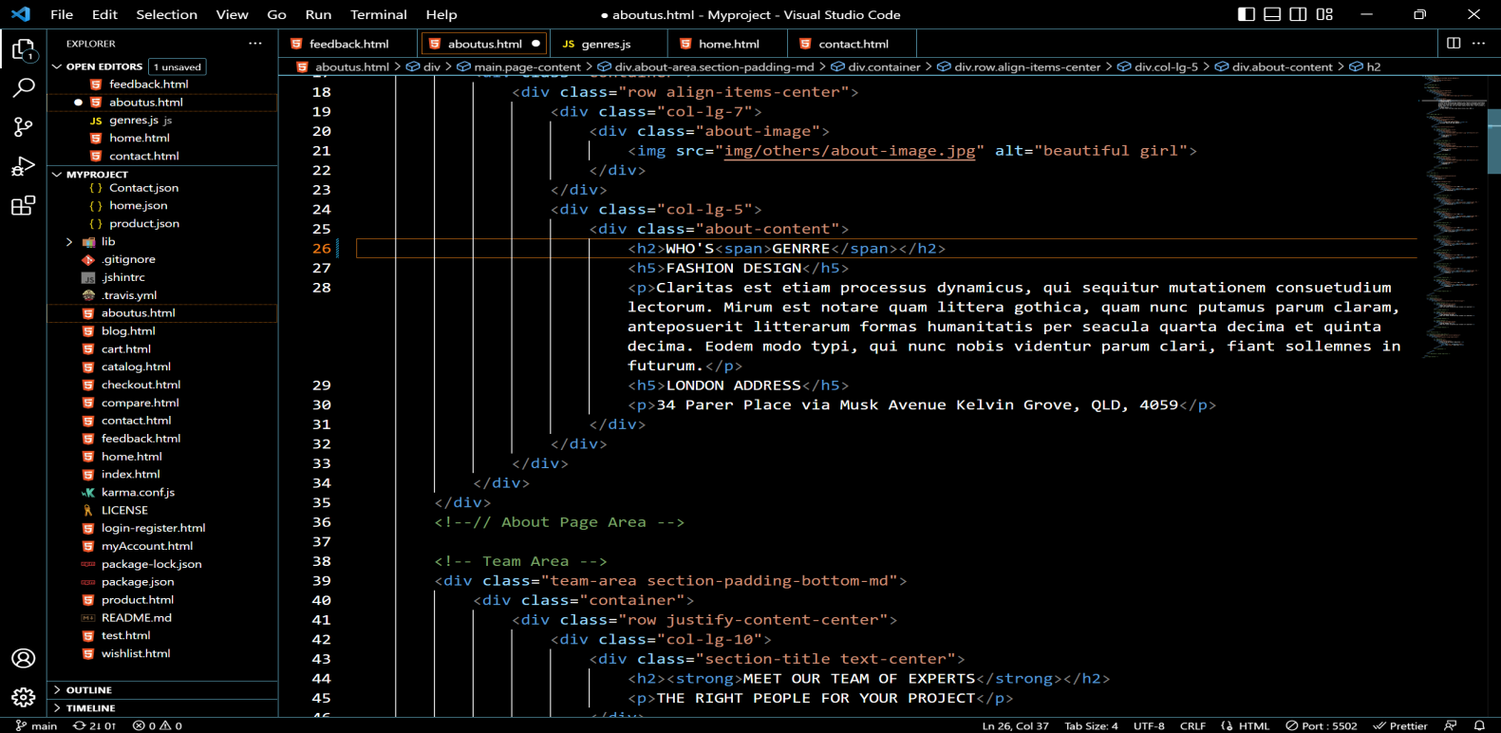

**Contact Us page**

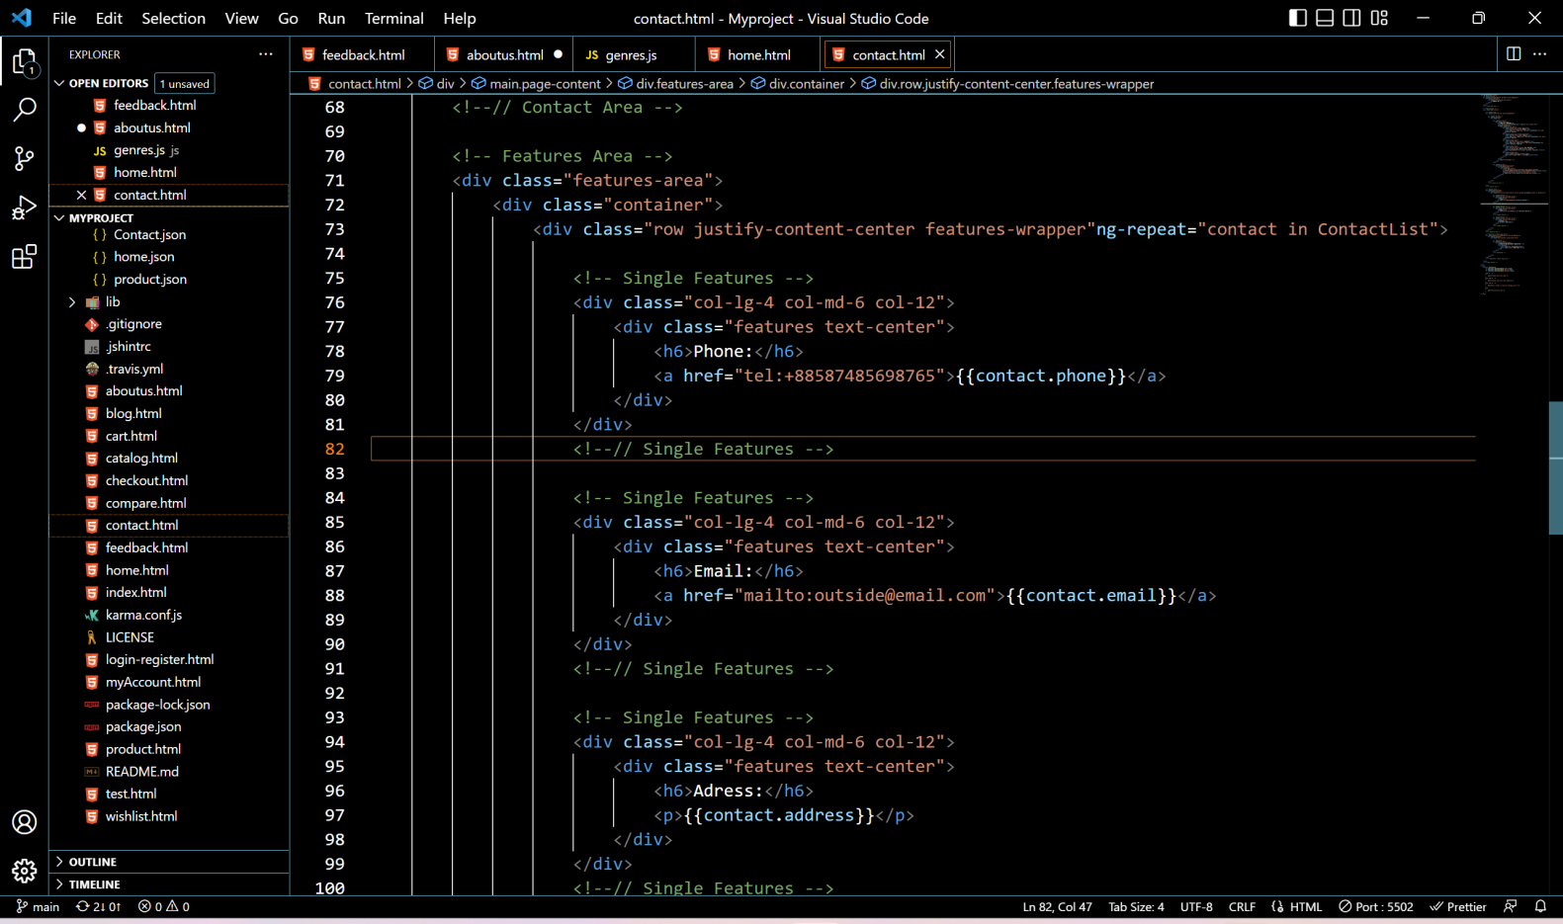

**Style.css**

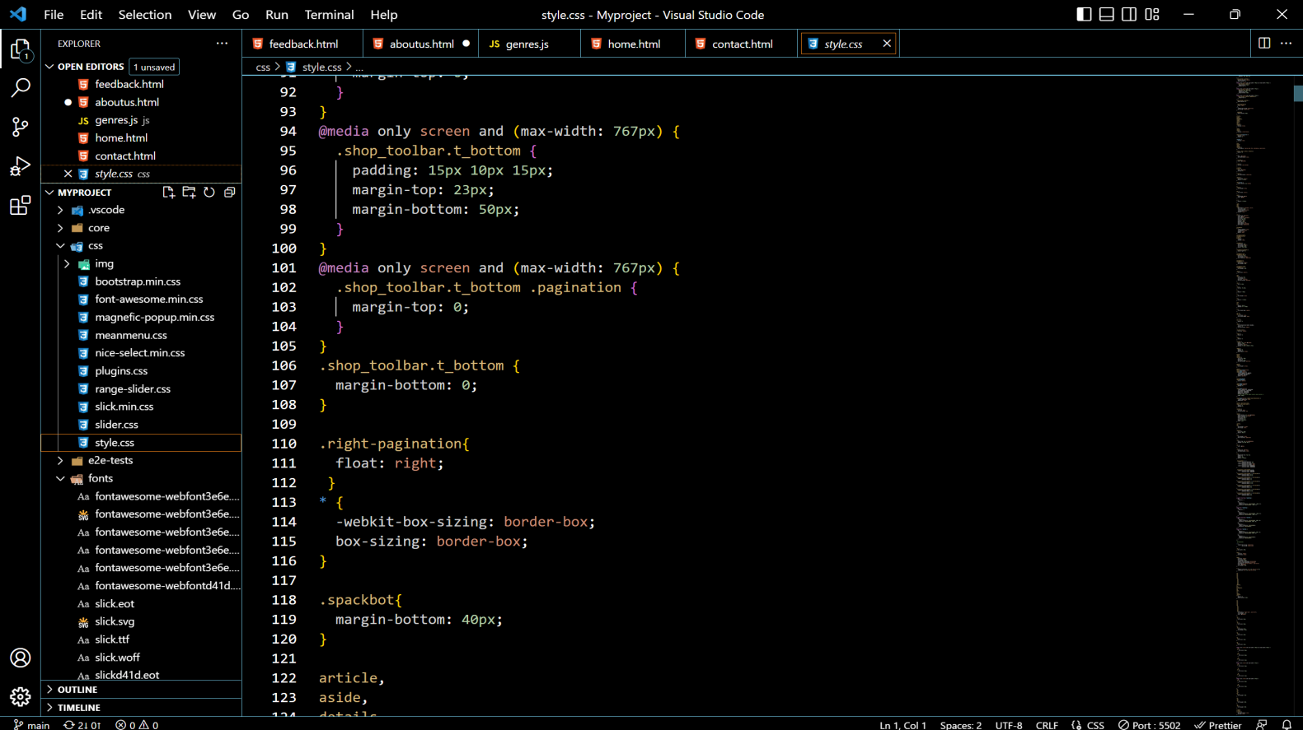

**app.js**

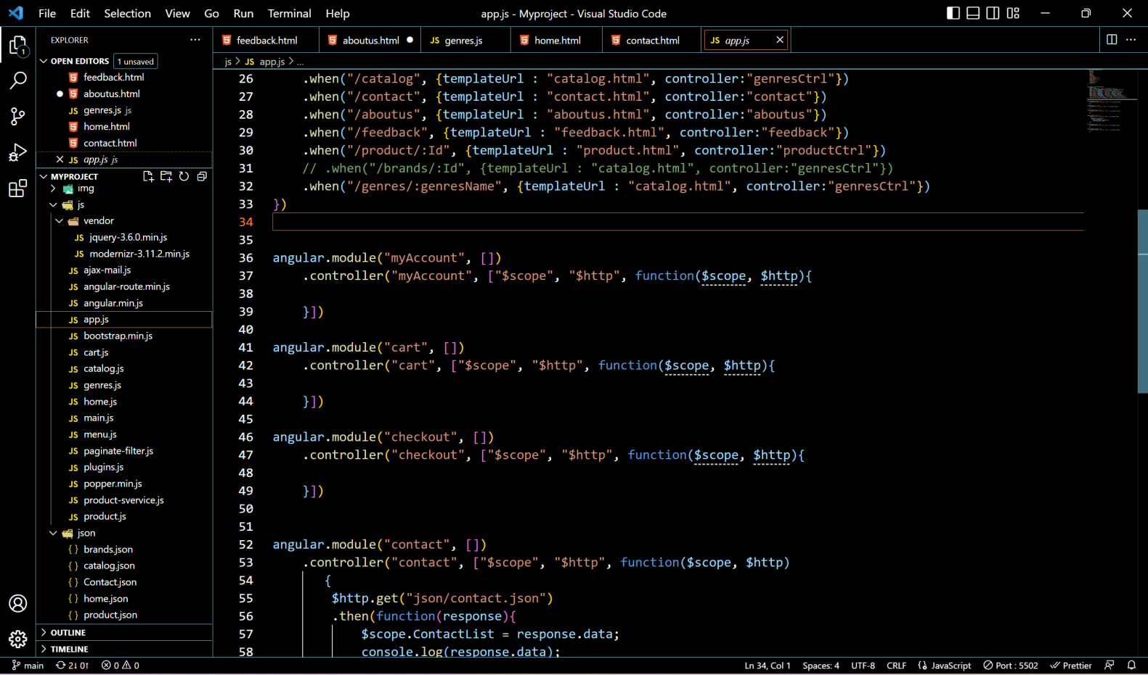

# TASK SHEET REVIEW 3

|  |  |  |  |  |  |  |  |
| --- | --- | --- | --- | --- | --- | --- | --- |
| **Project Ref. No.:**  **eP/Advertisement**  **Portal Management System/01** | | **Project Title:** | **Activity Plan Prepared By:** | **Date of Preparation of Activity Plan:** | | | |
| **Sr.**  **No.** | **Task** | **Actual**  **Start Date** | **Actual Days** | **Team**  **Mate Names** | **Status** |
| 1 | Home page | A1uniform | Chuong | 06-Jan-2023 | 1 | Chuong,Dan | Completed |
| 2 | Products | 06-Jan-2023 | 1 | Thien,Chuong | Completed |
| 3 | Brand | 06-Jan-2023 | 1 | Vi,Dan | Completed |
| 4 | Feedback | 06-Jan-2023 | 1 | Vi,Dan | Completed |
| 5 | Contact us | 06-Jan-2023 | 1 | Chuong,Thien | Completed |
| 6 | About us | 06-Jan-2023 | 1 | Vi,Dan | Completed |

|  |  |
| --- | --- |
| **Date: 06/01/2023** | |
| Signature of Instructor:  Tai  **Mr. Nguyen Phat Tai** | Signature of Team Leader:  Chuong  **Mr. Nguyen Ngoc Thanh Chuong** |